

PROJECT REPORT

Su92-bsaim-f24-006

BSAI-4A

Project Title:
Text Summarization System using Natural Language Processing (NLP)&Flask
GITHUB LINK: https://github.com/Sadii2005/programming-for-AI-THEORY

1. Introduction
With the increasing amount of digital information, it becomes difficult for users to read long articles, documents, or reports. Text summarization is a Natural Language Processing (NLP) technique that automatically shortens text while preserving its main meaning. This project aims to build an automated system that generates concise summaries from large text inputs.

2. Problem Statement
Large textual data is time-consuming to read and analyze. Users need a system that can quickly extract key information from lengthy documents without losing important meaning. Manual summarization is slow and inefficient, so an automated solution is required.

3. Objectives
- To process and clean raw text data.
- To extract important features from the text.
- To generate meaningful summaries automatically.
- To reduce reading time while preserving key information.
- To build a simple user-friendly interface (optional Flask web app).

4. Types of Text Summarization

1. Extractive Summarization
- Selects important sentences from original text.
- Uses algorithms like TF-IDF, TextRank.

2. Abstractive Summarization
- Generates new sentences using deep learning.
- More human-like summaries.

5. Tools and Technologies
- Programming Language: Python
- NLP Libraries: NLTK, SpaCy, Gensim
- Machine Learning (optional): Scikit-learn
- Deep Learning (optional): Transformers (BERT, T5)
- Framework (optional): Flask
- Frontend: HTML, CSS

6. Methodology / Working Principle

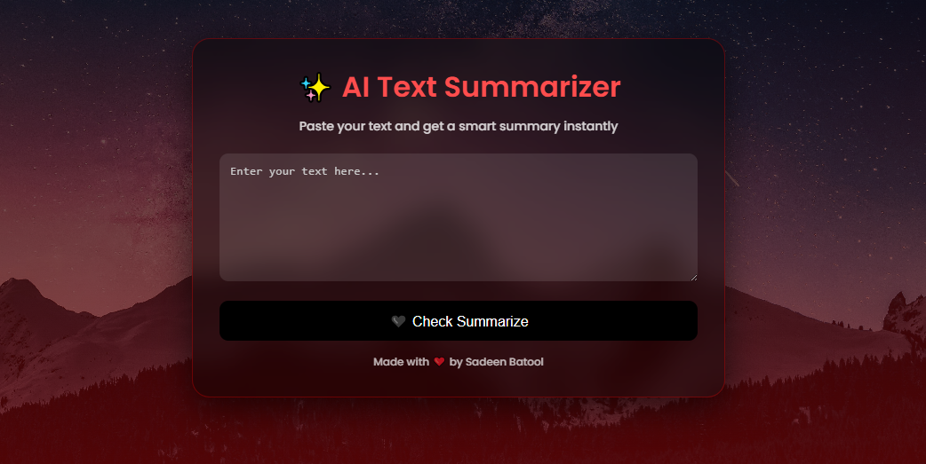

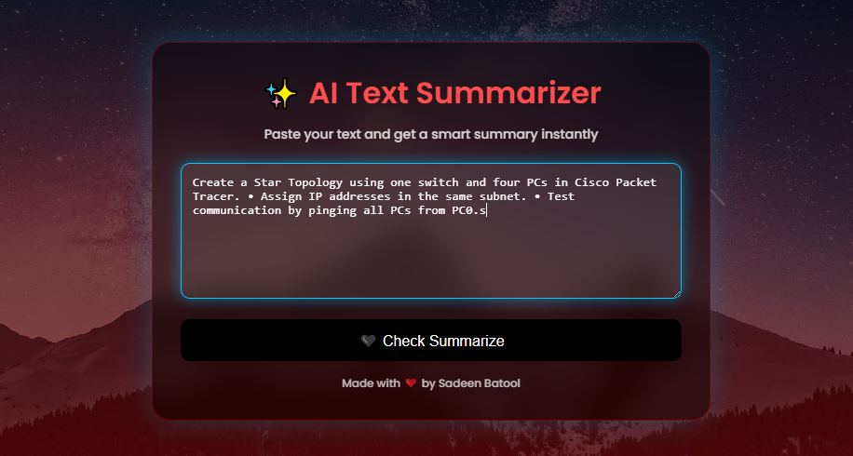

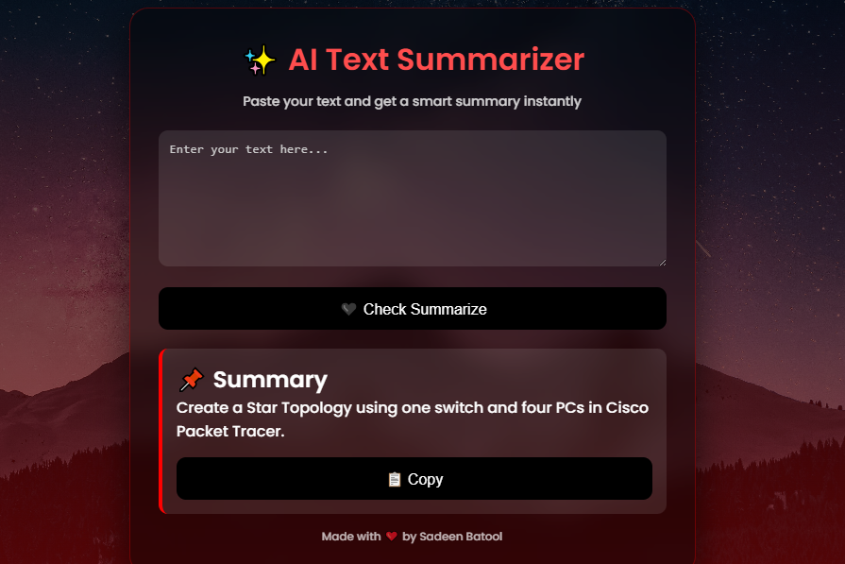

- Input Text Collection
  - User provides long paragraph or document.
- Text Preprocessing
  - Tokenization
  - Stopword removal
  - Lowercasing
  - Cleaning punctuation
- Feature Extraction
  - Sentence scoring using TF-IDF or TextRank algorithm.
- Sentence Ranking
  - Important sentences are ranked based on relevance.
- Summary Generation
  - Top-ranked sentences are combined to form summary.
- Output
  - System displays short, meaningful summary.

7. System Architecture
User Input → Text Preprocessing → Feature Extraction → Sentence Ranking → Summary Generation → Output Display

8. Expected Outcome
- A working NLP system that generates summaries.
- Reduced text length while preserving meaning.
- Improved reading efficiency for users.
- Optionally, a web-based interface using Flask.

9. Applications
- News summarization
- Research paper summarization
- Document analysis
- Educational notes compression
- Business report summarization

10. Future Enhancements
- Use transformer models (BERT, T5, GPT-based summarization)
- Support multiple languages
- Add voice input/output
- Integrate with document upload system (PDF/DOCX)
- Real-time web scraping summarization

11. Conclusion
This project provides an efficient way to convert large text into short meaningful summaries using NLP techniques. It helps users save time and improves information understanding. The system can be further enhanced using deep learning models for more accurate and human-like summaries.

